**Triggers Exercise**

**(Use IQSchool DB)**

**NOTE: These questions are not in order of increasing difficulty**

1. In order to be fair to all students, a student can only belong to a maximum of 3 clubs. Create a trigger to enforce this rule.
2. The Education Board is concerned with rising course costs! Create a trigger to ensure that a course cost does not get increased by more than 20% at any one time.
3. Too many students owe us money and keep registering for more courses! Create a trigger to ensure that a student cannot register for any more courses if they have a balance owing of >$500.
4. Our school DBA has suddenly become allergic to Foreign Key constraints and has disabled them in the database! Create a trigger on the Registration table to ensure that only valid CourseID’s, StudentID’s and StaffID’s are used for grade records. Use sp_help tablename to find the name of the foreign key constraints you need to disable to test your trigger. Try and have the trigger raise an error for each foreign key that is not valid. If you have trouble with this question create the trigger so it just checks for a valid student ID.
5. Contrary to the advice of the school doctor, the DBA still thinks he is allergic to Foreign Key constraints! Yikes! Create a trigger on the Student table that will ensure that we do not delete any students that have made payments, have Registration records, or belong to any clubs.
6. 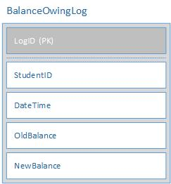Not only has the school DBA come down with some mysterious allergy but our network security officer suspects our system has a virus that is allowing students to alter their Balance Owing! In order to track down what is happening we want to create a logging table that will log any changes to the balanceowing in the student table. You must create the logging table and the trigger to populate it when a balance owing is updated.
7. We have learned it is a bad idea to update primary keys. Yet someone keeps trying to update the Club tables ClubID column and the Course tables CourseId column! Create a trigger(s) to stop this from happening! You are authorized to use whatever force is necessary! Well, in your triggers, anyways ☺!